Terraform Task

vim main.tf
provider "aws" {
region = "us-east-1"
}

provider "aws" {
alias = "mumbai"
region = "ap-south-1"
}

resource "aws_instance" "ec2_us" {
ami = "ami-0c02fb55956c7d316"
instance_type = "t2.micro"

tags = {
Name = "US-Instance"
}
}

resource "aws_instance" "ec2_mumbai" {
provider = aws.mumbai
ami = "ami-03f4878755434977f"
instance_type = "t2.micro"
subnet_id = "subnet-05b01ad56e3f2702c"

tags = {
Name = "Mumbai-Instance"
}
}

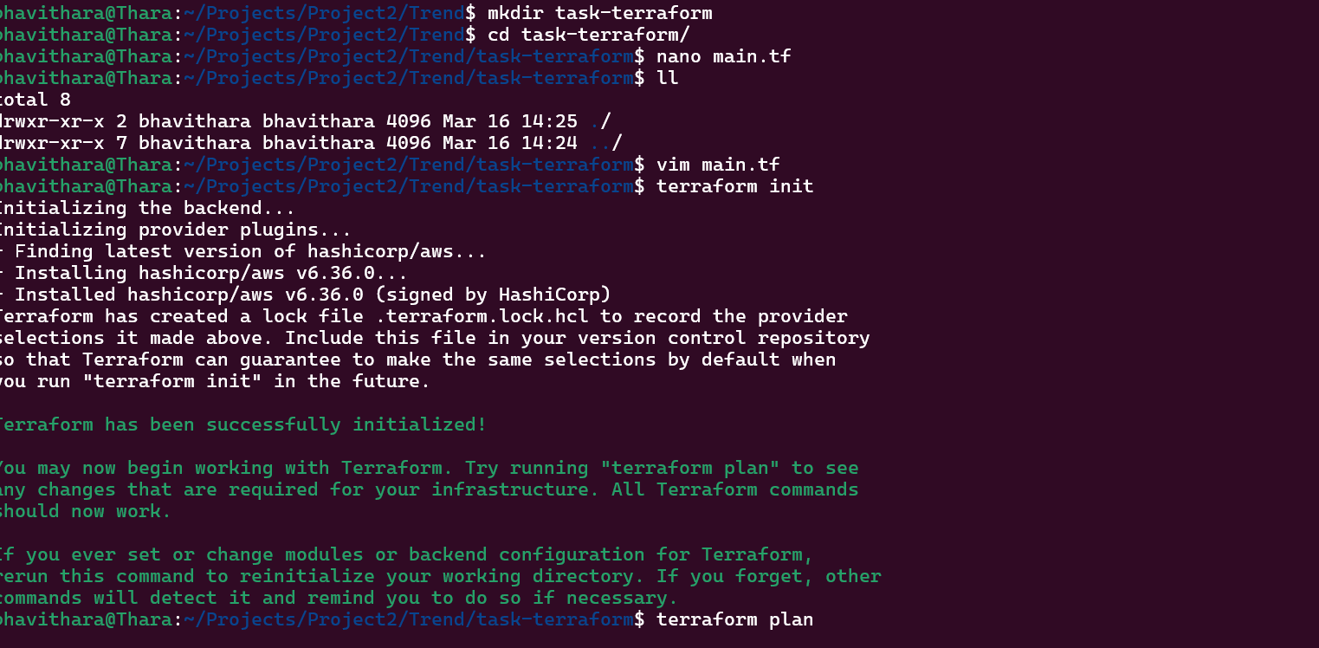

Terraform init
Terraform plan
Terraform apply
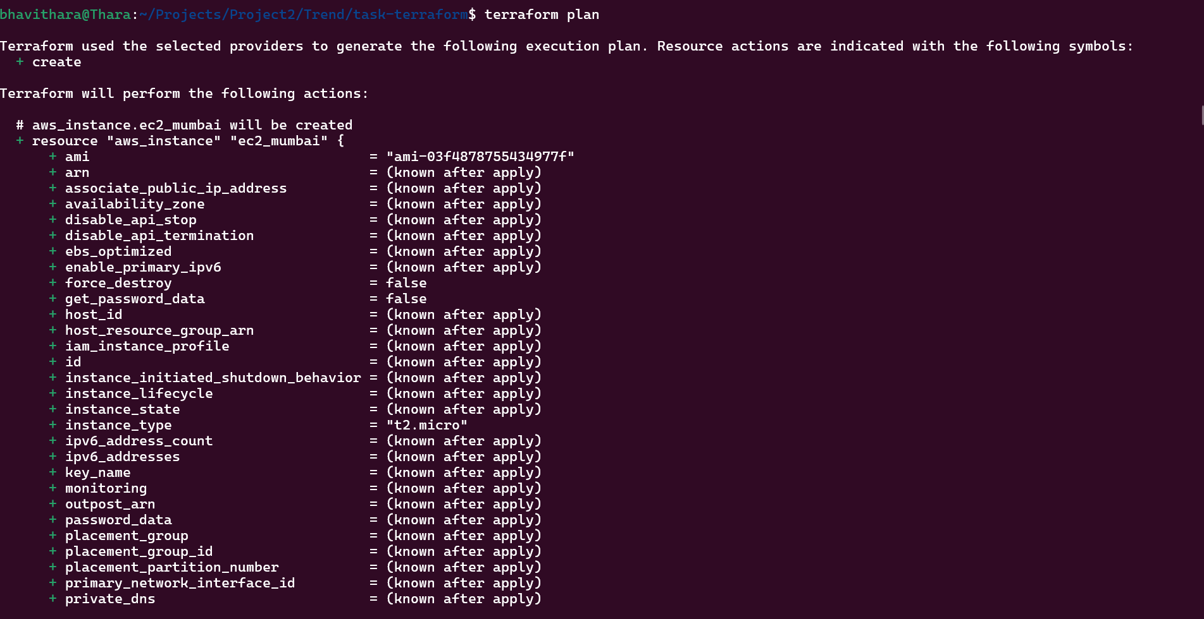

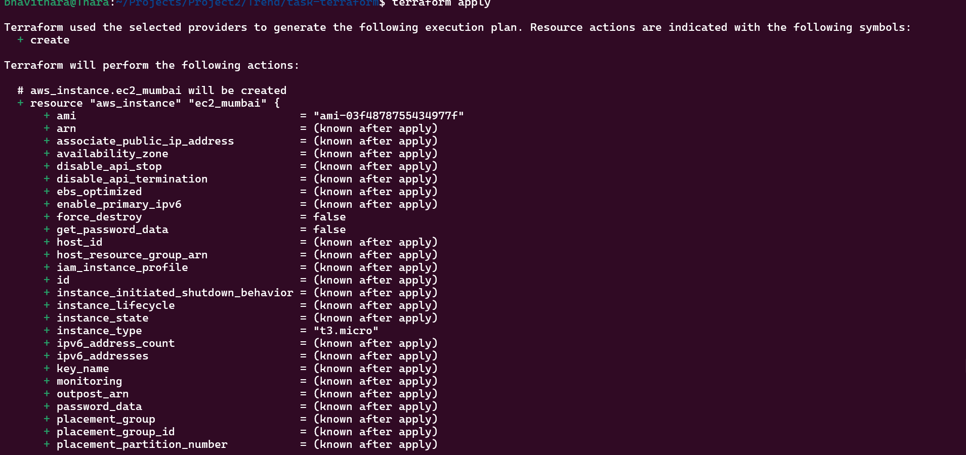

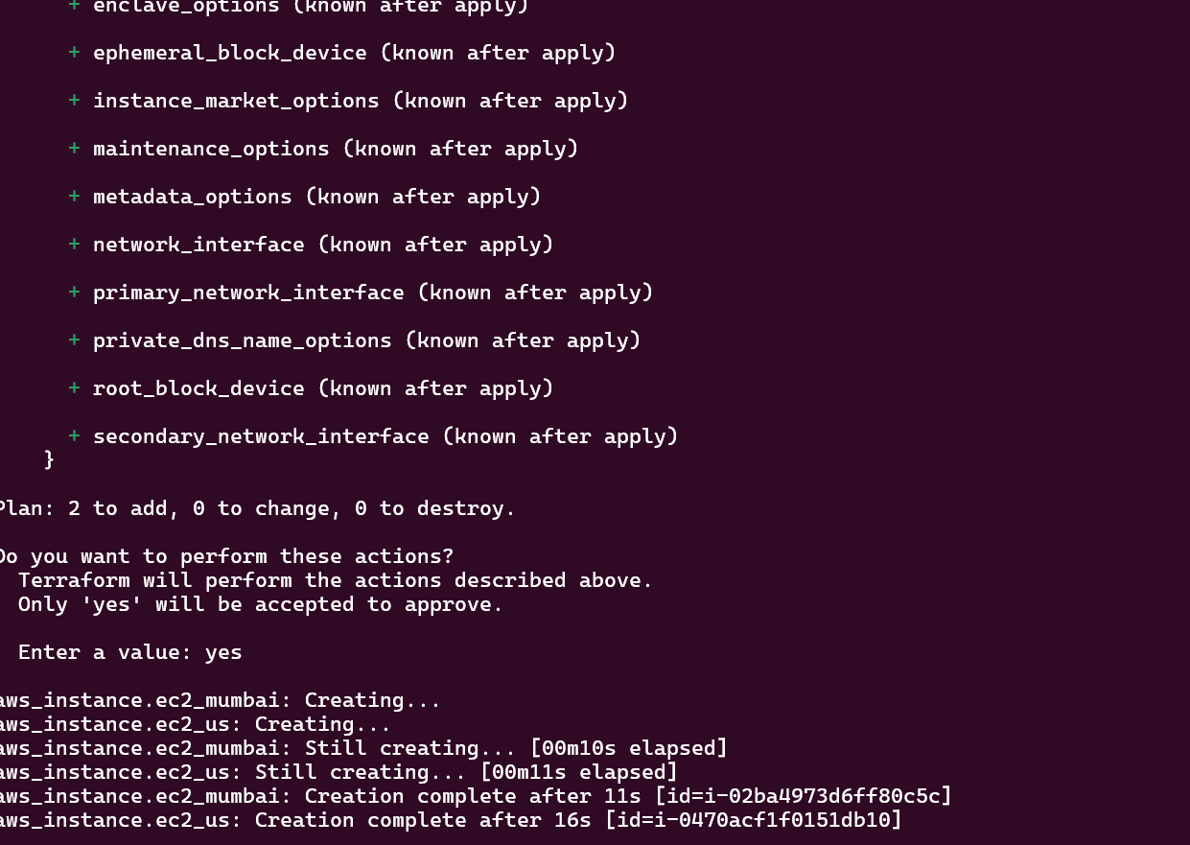

EC2 Instance in Mumbai:

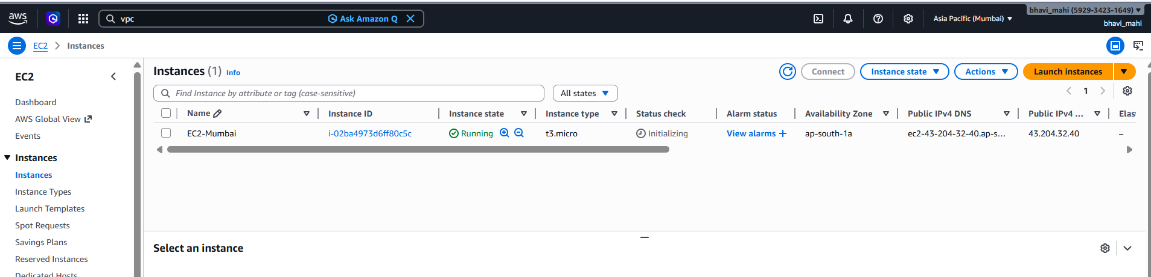

EC2 Instance in US-East1
